Query the list of *CITY* names from **STATION** that *do not start* with vowels. Your result cannot contain duplicates.

**Input Format**

The **STATION** table is described as follows:

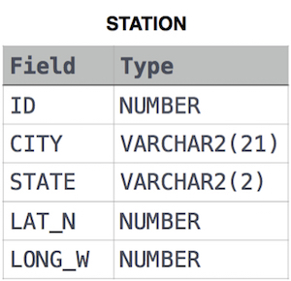

where LAT_N is the northern latitude and LONG_W is the western longitude.